## The TARDIS Project Demonstration

### Sprint 1

1. Discuss and explore the ConsoleUtil class.
2. Models
   1. Character.cs
      1. Enum RaceType
      2. 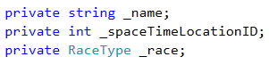
      3. Add Constructor with 3 parameters
   2. SpaceTimeLocations.cs
      1. 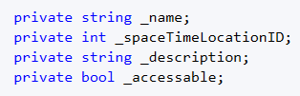
   3. Traveler.cs
      1. Add Constructor with 3 parameters and reference to base class

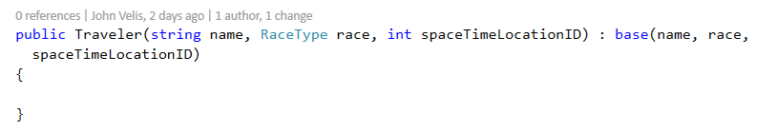

* 1. TravelerAction.cs
     1. Explore
  2. Universe.cs
     1. Add list of SpaceTimeLocations with auto implemented property
     2. Add constructor and initialize the list
     3. Note GetSpaceTimeLocationByID() method

1. Program
   1. Instantiate a Controller object
2. Controller
   1. Note bool fields: _usingGame and _missionInitialized
   2. Add objects fields

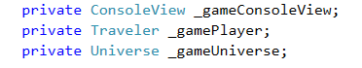

* 1. Complete the constructor

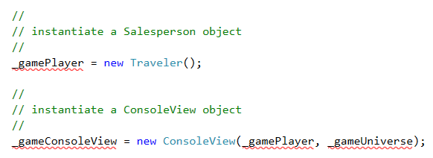

* 1. Complete InitializeGame

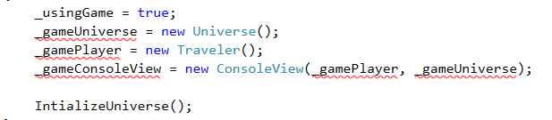

* 1. Explore InitializeUniverse() method
  2. Explore ManageGameLoop and DisplayGetTravelerActionChoice
  3. InitializeMission
     1. DisplayMissionSetupIntro()
     2. DisplayGetTravelersName()
     3. DisplayGetTravelersRace()
     4. DisplayGetTravelersNewDestination()
        1. Universe.GetSpaceTimeLocationByID
           1. Exception thrown

1. ConsoleView
   1. Add object fields



* 1. Initialize object fields in constructor
  2. Update InitializeConsole

1. Start coding out menu
   1. Mission Setup
      1. DisplayMissionSetupIntro()
      2. DisplayGetTravelersName()
      3. DisplayGetTravelersRace()
      4. DisplayGetTravelersNewDestination()
         1. Universe.GetSpaceTimeLocationByID
            1. Exception thrown
      5. DisplayMissionConfirmation()
   2. DisplayTravelerInfo()

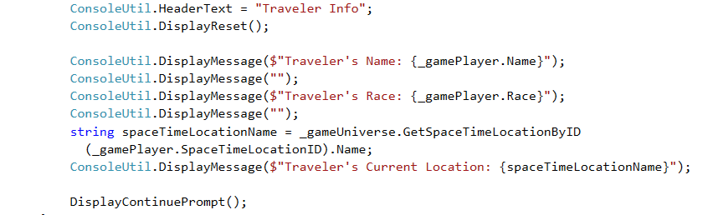

* 1. DisplayListAllTARDISDestinations()
  2. DisplayLookAround()



### Sprint 2

1. Create the Object abstract class.
2. Create the Jewel class and inherit from the Object class.
3. Create the Furniture class and inherit from the Object class.
4. Create the GallifrianMirror class and inherit form the Object class.
5. ff